GDP Forecasting- Project Notes

Contents

**Project Objectives** 3

**GDP FORECASTING IN THE UK** 5

Office of National Statistics 5

Data 5

APPROACHES TO GDP FORECASTING 5

Descriptive Analysis of the GDP 7

Seasonal ARIMA Model 7

GDP FORECASTING: RESULTS 8

Accuracy Parameters 10

**GDP FORECASTING IN AUSTRALIA** 11

Melbourne Institute 11

Australian Bureau of Statistics 11

Reserve Bank of Australia 11

APPROACHES TO GDP FORECASTING 12

Hierarchical Approach 12

ARIMAX Model 12

Accuracy Parameters 13

GDP FORECAST RESULTS 14

# **Project Objectives**

|  |  |  |
| --- | --- | --- |
| **Phase** | **Scope of Work - Project Stages** | **What MCC needs to provide?** |
| 1 | Project Initiation and Planning | MCC team to attend kick-off workshop/ sessions |
| Data Collection | Identifying and categorizing the key sectors that contribute significantly to Abu Dhabi's GDP.  Gathering historical data for the identified indicators over a specific time period.  Ensuring data quality and accuracy through data cleaning and validation processes.  Organizing and maintaining a comprehensive database of GDP-related data. |
| Data Analysis | A comprehensive analysis of each sector will be conducted to understand its unique characteristics, trends, drivers, and challenges.  Conducting statistical analysis to understand the historical behaviour of GDP.   Identifying any seasonality, cyclicality, or outliers in the data that may impact GDP forecasts.  Utilizing econometric techniques to examine the relationships between GDP and various economic variables. |
| 2 | Model Development | Selecting appropriate econometric models based on the characteristics of the GDP data and the objectives of the forecast.  Building regression models, time series models (such as ARIMA or SARIMA), or other relevant models to capture GDP growth dynamics.  Incorporating relevant independent variables into the models.  Calibrate and validate the models using historical data to ensure their accuracy and reliability. |
| Forecasting | Utilizing the developed models to generate forecasts of future GDP for the specified time horizon.  Forecasting techniques such as extrapolation, time series decomposition, or scenario analysis will be applied to project GDP trends.  Various assumptions and scenarios to account for uncertainties and potential shocks in the economy will be considered.  Updating the forecasts based on any new economic data and information. |
| Scenario Drivers Identification and Analysis | Identifying key scenario drivers that can significantly impact GDP.  Defining different scenarios based on plausible variations in these drivers, considering both optimistic and pessimistic scenarios.  The impact of external factors, such as global economic conditions, geopolitical events, and natural disasters, on GDP growth scenarios will be considered. |
| Model Deployment & Automation | Continuously monitor economic indicators and factors that influence GDP growth.  Comparison of the forecasted GDP rates with the actual observed values to assess the accuracy and reliability of the forecasts. |
| 3 | UI&UX design and visualization | Reporting and Presentation: Generation of comprehensive reports and presentations that present the forecasted GDP, underlying methodologies, and assumptions.  Ensure compatibility of the model output with the current setup of REST API created by NodeJS on the backend.  Utilize the Highcharts library to display model output as visualizations |
| Platform implementation | Implementation of final results on internal web-based platform.  Enable seamless integration and binding with the current Angular 10 frontend for the visualizations using the Highcharts library. |
| Defect Supports and Maintenance | Analyse forecast errors and identify any patterns or biases that need to be addressed.  Ensure the reliability and functionality of the visualization tools and address any technical issues that may arise |
| Transfer Knowledge and Stakeholder Engagement | Facilitate discussions and provide explanations to stakeholders regarding the implications of the forecasted GDP and to give policy recommendations.  Address questions, concerns, and feedback from stakeholders to ensure a comprehensive understanding of the forecast results.  Communicate the forecast results, potential risks, and uncertainties to stakeholders in a clear and understandable manner. |

# **GDP FORECASTING IN THE UK**

The rate of growth — of decline — of the GDP has a profound impact on various aspects of the economy, such as investment, international trade, tax revenues, business development and tax revenue. That’s why GDP forecasts are critical for informing decisions, planning and growth.

### Office of National Statistics

The Office of National Statistics (ONS) provides National Statistical Information (NSI) to the UK government. ONS publishes [monthly UK GDP estimates, data and analysis](https://www.ons.gov.uk). GDP estimates provided by ONS are revised in accordance with domestic economic changes.

ONS provides [time-series analysis](https://www.ons.gov.uk/economy/grossdomesticproductgdp/bulletins/gdpfirstquarterlyestimateuk/latest) of the data. Key sectors that affect UK GDP data are exports, imports, and household consumption.

ONS provides clean and accurate data alongside valuable visualizations for time-series analysis.

### Data

The country’s historical GDP data in the form of time series is contained in the file gdp_uk.xlsx and it contains 267 entries.

For the sake of simplicity, it is recommended to limit the scope of data to the first quarter of 1980 and remove the undesired values that disturb the series characteristics.

## APPROACHES TO GDP FORECASTING

A Seasonal ARIMA model will be used for analysis as it is quite popular and easy to implement. A seasonal ARIMA model is relevant due to its accuracy and the timeliness of the parameters used for analysis.

Although Vector Autoregression (VAR) or Bayesian Vector Autoregression (BVAR) models are pretty popular, they are too complicated and difficult to implement. BVAR is more popular than VAR because it adds Bayesian dimension to VAR that allows for more flexible and advanced modelling.

The Bank of England (BoE) uses at least 24 different models to forecast GDP and then averages the parameters using a BVAR model. An ARIMA model, on the other hand, is much simpler can be executed using R.

[HEGY test is a reliable method to ensure the seasonality.](https://www.sciencedirect.com/science/article/abs/pii/030440769090080D) It enables us to conduct t-test and F-test analysis.

In the context of the HEGY test, the t-test and F-test are statistical tests used to assess the significance of the estimated seasonal dummies in a time series regression model. The HEGY test is commonly used to test for the presence of seasonality in a time series and, if seasonality is detected, to determine the appropriate seasonal dummies to include in a regression model.

We have implemented the HEGY test hypothesis combinations.

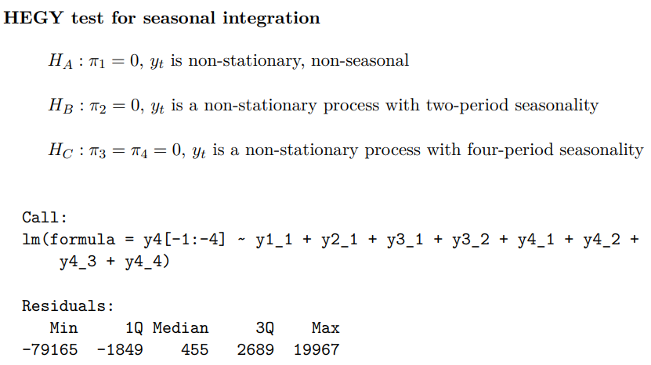

We have used a sampled based on quarterly historical GDP data. Still, it is imperative to perform a HEGY test to check seasonality. The HEGY test confirmed that our time series sample data has a semi-annual stationarity and it can be seen in the following table:

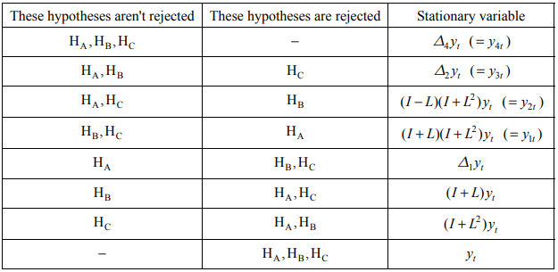

### Descriptive Analysis of the GDP

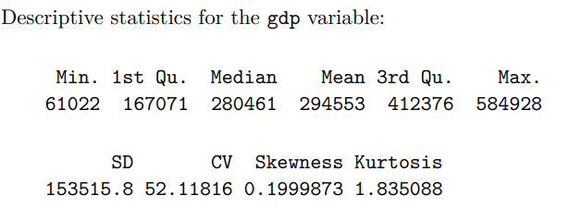

### Seasonal ARIMA Model

In SARIMA modeling, which is an extension of the ARIMA (Autoregressive Integrated Moving Average) model, you have various parameters to consider, including the orders of autoregressive (p), differencing (d), and moving average (q) components, as well as the seasonal orders of these components (P, D, Q, and s for seasonality).

Based on the HEGY test results, the parameters p and q in the SARIMA model will have the value of 1. The unknown optimal values have been replaced with parameter values between 0 to 2.

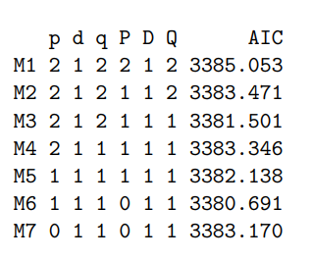

The Akaike Information Criterion (AIC) is a statistical measure used in the context of time series modeling, including the Seasonal Autoregressive Integrated Moving Average (SARIMA) model. AIC is a tool for model selection and evaluation, helping you choose the most appropriate SARIMA model for a given dataset.

Based on the Akaike Criterion (AIC), the best model is the model 6.

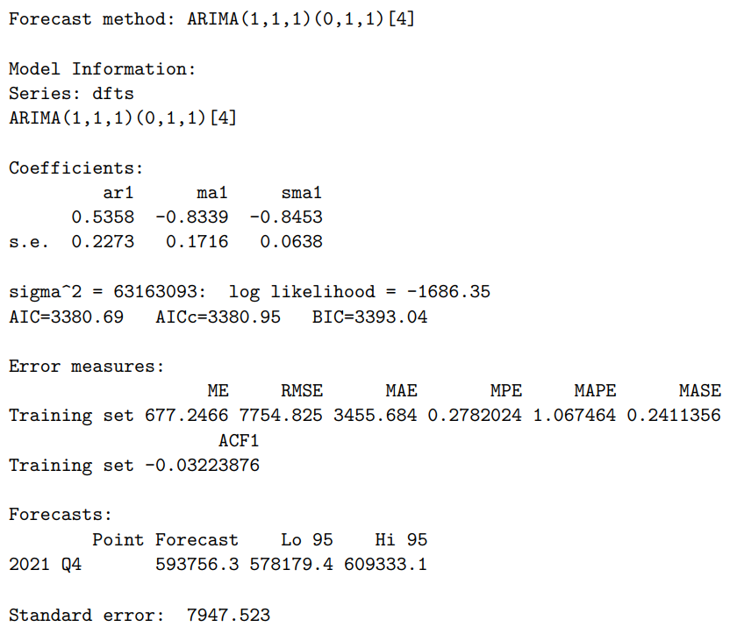

## GDP FORECASTING: RESULTS

Every method of forecasting comes down to one thing: accuracy. We have analyzed historical GDP data provided by ONS and concluded that UK GDP is likely to remain steady for the years 2020-2024.

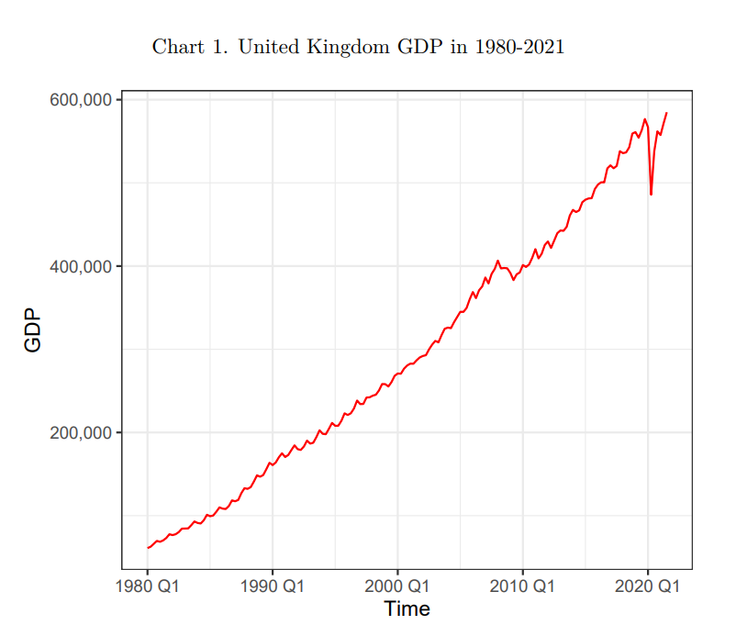

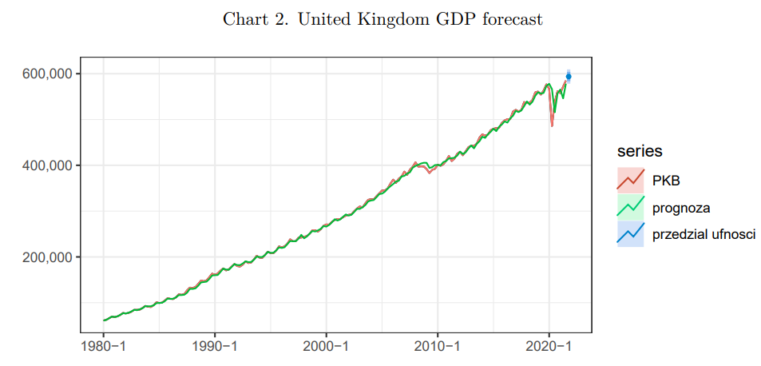

### Accuracy Parameters

Common accuracy parameters used for historical GDP analysis and forecasts are **ME, RMSE, MAE, MPE, MAPE, and MASE**. However, it is important to ensure that a suitable model is used for forecasting and there are no structural breaks in the data.

#### CUMSUM Stability Test

A **CUMSUM Stability Test** can be conducted to ensure that a suitable model used for forecasting. A CUMSUM test calculates the cumulative sums of the forecast errors, plots these errors against time, and examines the plot for any significant departures from a straight line. The CUMSUM results for the sample data can be seen below:

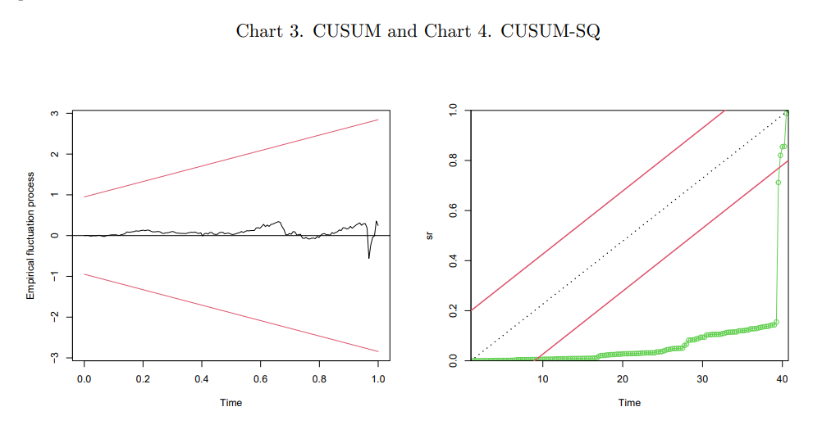

#### Chow Stability Test

The Chow Stability Test is a statistical test used to assess whether there has been a significant structural change or instability in a time series dataset, especially when regression or forecasting models, like ARIMA, have been applied. It is named after the economist Gregory Chow, who developed this test.

In other words, a Chow Stability Test can ensure that there are no structural breaks in our GDP forecasts. The Chow Stability Test results for the sample data can be seen below:

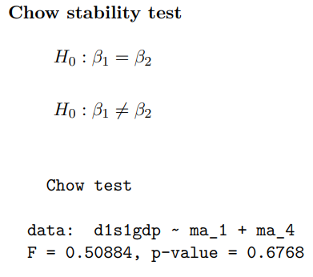

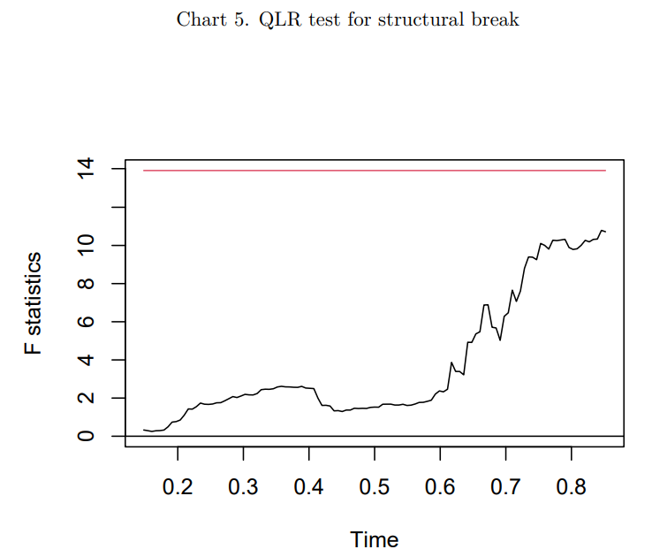

# **GDP FORECASTING IN AUSTRALIA**

Australia’s annual GDP is the value of all goods and services produced within the country’s borders within a year. Forecasting the GDP is important as it helps facilitate strategic decision making by the Australian government and businesses.

### Melbourne Institute

The Melbourne Institute publishes reports that predict macroeconomic indicators, such as GDP, using the time series data. The Melbourne Institute uses monthly or quarterly data to make GDP forecasts. These are published in the journal known as [“Melbourne Institute Nowcast of Australian GDP.”](https://melbourneinstitute.unimelb.edu.au/__data/assets/pdf_file/0003/4734147/Nowcast-Aug-2023.pdf)

### Australian Bureau of Statistics

The Australian Bureau of Statistics (ABS) provides [official GDP estimates](https://www.abs.gov.au/statistics/economy/national-accounts/australian-national-accounts-national-income-expenditure-and-product/latest-release). Key sectors that affect Australian GDP data are exports and investments. ABS provides clean and accurate GDP data and visualizations for observing past trends.

### Reserve Bank of Australia

— The Reserve Bank of Australia (RBA) is tasked with managing the country's monetary policy, which involves determining the appropriate interest rates. As a result, it is crucial for this public institution to possess a comprehensive understanding of the economy's trajectory, and the GDP serves as a critical indicator in this regard.

— The Australian central bank [regularly releases its GDP projections and other forecasts through its quarterly statements of monetary policy](https://www.rba.gov.au/publications/smp/forecasts-archive.html).

## APPROACHES TO GDP FORECASTING

Australian public institutions have a wide array of models at its disposal for the purpose of forecasting various economic indicators including the GDP. The RBA uses full-system models to make GDP predictions.

While it may seem tempting to use complex approaches to make Australian GDP predictions, it is best to use ARIMA as a baseline approach. The hierarchical approach can be implemented by using ARIMA as the baseline approach.

### Hierarchical Approach

The [hierarchical approach](https://arxiv.org/pdf/2004.03864.pdf) to estimate and forecast Australian GDP is popular and useful. It depends on income and expenditure mostly.

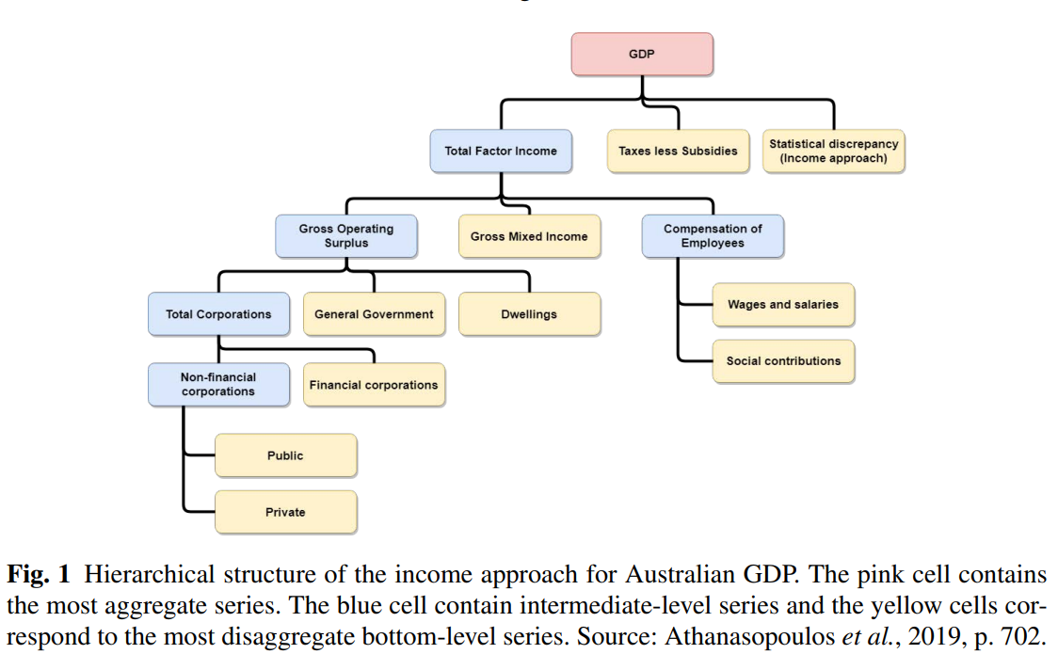

### ARIMAX Model

It is wise to use an ARIMA model due to accuracy and nature of the data.

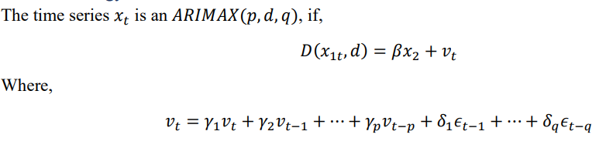

ARIMAX is usually preferred because the [process of constructing ARIMAX](https://hcommons.org/deposits/item/hc:45561/) can be divided into just four steps.

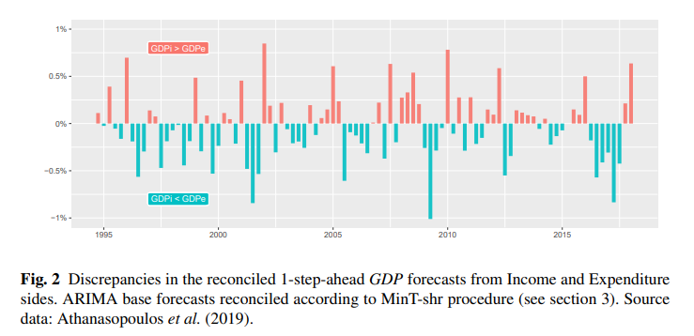

As you can see, discrepancies in forecasts can be a problem. Therefore, it is a popular practice to use a combination of ARIMA and hierarchical modelling to forecast GDP. ARIMA model can be used as a crucial first reconciliation base.

Simple univariate ARIMA models can be selected using the auto.arima function of the R-package forecast.

### Accuracy Parameters

MSE is used to evaluate the accuracy of the results. The positive values indicate an improvement in forecasting accuracy.

## GDP FORECAST RESULTS

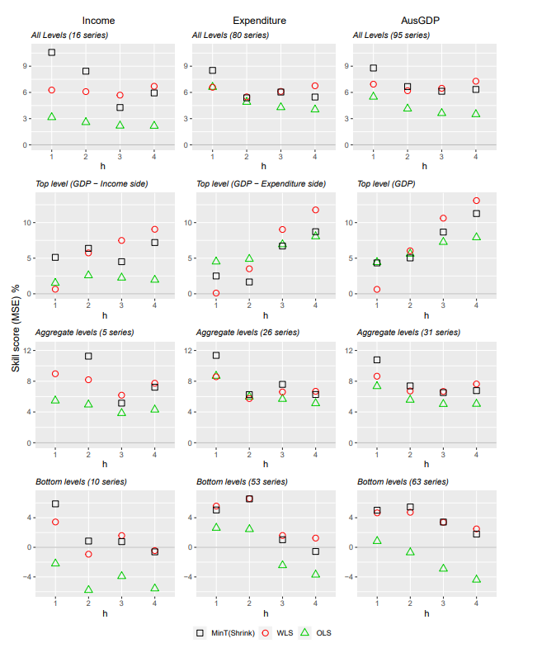

It can be concluded that a reconciliation of the ARIMA and hierarchical models can produce accurate Australian GDP forecasts.